Water Foundation

Program Officer, Healthy Watersheds Program
(Sacramento or Oakland, CA)

The Opportunity

The Water Foundation seeks a self-directed and motivated Program Officer to work in its Watersheds Program to address the complex challenges of water in the western United States. Reporting to the Senior Program Officer, the Program Officer will work directly with grantees, consultants, and partners to achieve the Water Foundation’s priority objectives. The Program Officer will preferably be based at Water Foundation’s offices in Sacramento or Oakland, CA.

The ideal candidate is an environmental or natural resources professional with expertise, experience, and education (or comparable knowledge) in freshwater law or policy, conservation science, land or water management, or related fields. Candidates with direct experience partnering with indigenous peoples and/or working with diverse stakeholders on water/watershed issues in rural and agricultural settings in the Western states are highly preferred. Seven to ten years of substantive, relevant work experience in nonprofits, philanthropy, political organizing, business, or government is required. Experience working on advocacy campaigns is a plus.

Healthy Watersheds Program

The Healthy Watersheds program emphasizes the management of four critical components of a watershed—groundwater, floodplains, forests, and flows. The program promotes multi-benefit solutions and efforts to modify and modernize the design and operation of traditional “gray” infrastructure so that people and nature can thrive. It invests in some of the West’s most significant and storied watersheds, including the Sacramento-San Joaquin basin, the Salton Sea and Lower Colorado River basin, the Snake River basin, and the Rio Grande. The Healthy Watersheds program recognizes the critical role of indigenous communities and tribal governments in river conservation and restoration and the protection of treaty rights. It also works closely with agricultural interests to sustain both public health and freshwater ecosystems, while maintaining sustainable food production.

The Healthy Watersheds program partners closely with the Healthy Communities program, which is focused on the human dimensions and impacts of watershed management, including the fact that millions of Americans live in places where safe water is not available, or where they are increasingly threatened by floods, droughts, fires, and climate change. Together, the Healthy Watersheds and Healthy Communities program prioritize three systems interventions: 1) changing the ways we move and share water; 2) broadening who makes water decisions and how; and 3) strengtheingn the stories we tell about water. These interventions take aim at the

physical, institutional, and cultural drivers of our current water system.

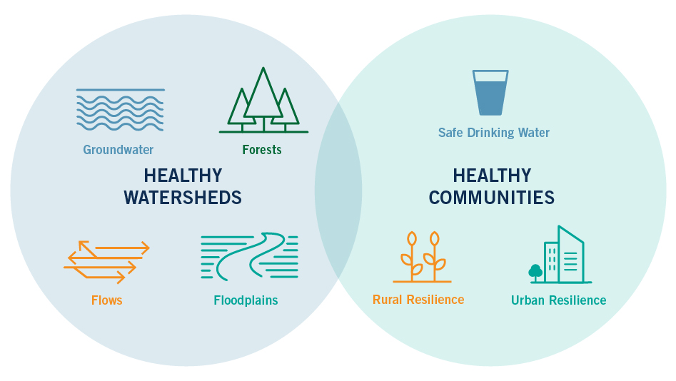

About the Organization

The Water Foundation is a nonprofit philanthropy working to support lasting water solutions for communities, economies, and the environment. The Foundation complements strategic grantmaking with creative field-building and engagement with high-level decision makers and community leaders, and helps funders identify and act on opportunities to better manage water.
The Water Foundation launched as the California Water Foundation in 2011, operating as an initiative of the Resources Legacy Fund. In January 2017, the Foundation transitioned to become an independent, public foundation. With this transition, the Foundation has expanded its focus to key watersheds across the West, recognizing that water crosses political boundaries and natural places face similar challenges across the region. As a singularly focused water funder, the Water Foundation serves the entire water field, deploying staff expertise to move resources to the groups that can most effectively improve water systems that affect people and nature. The Water Foundation’s partners span a broad spectrum: conservation organizations, agricultural associations, water providers, environmental justice groups, business groups, and local, state, and federal agencies.

In 2018, the Water Foundation developed an ambitious strategic framework to guide the efforts and impact of the organization in the coming years. This strategy, which reflects extensive field input from partners and stakeholders, takes a systemic approach. It prioritizes securing safe, clean water for people, restoring and sustaining freshwater environments, and building resilience to a changing climate. These three goals are critical to the future of water. In pursuing these goals, the Foundation will support the field in tackling immediate water problems, including polluted drinking water and collapsing ecosystems, in ways that alter system drivers, such as social inequality and outmoded infrastructure.

More information about the Water Foundation can be found at www.waterfdn.org.

Key Reponsibilities

Program Development
- Partner with the Senior Program Officer and Director of Programs and Strategy to craft strategy and shape program objectives.
- Collaborate with the program team and grantees to identify desired strategic water policy and management outcomes and design campaigns to achieve them.
- Conduct research and analysis and develop written assessments that inform the work of the program.
- Ensure close coordination and integration between the Healthy Watersheds and Healthy Communities programs.

Grantmaking and Monitoring
- Work with the Senior Program Officer to develop a portfolio of grants and contracts to achieve strategic outcomes.
- Conduct site visits, consult with grantees on how best to achieve desired impacts, and assess effectiveness with an eye toward learning and improvement.
- Invite, review, analyze, and summarize grant proposals and reports, shepherding them through Foundation review processes.
- Manage contractors working in support of grantees and/or the Foundation.
- Facilitate the ongoing individual and collective work of grantees and other partners, including linking them to resources that may help them reach project goals and supporting coordination and collaboration.

Coalition Building and Direct Engagement
- Cultivate partners from a wide range of interests and sectors.
- Build coalitions and convene stakeholder meetings that can advance program objectives as needed.
- Engage directly with governmental decision makers and community leaders to advance programmatic work in coordination with the Senior Program Officer.
- Serve as a resource to other funders, supporting their investment in water capacity and field-building.

Qualifications

- Seven to ten years of substantive, relevant work experience in in nonprofits, organizing, philanthropy, business, or government. Experience working on advocacy campaigns preferred.
- Advanced degree or comparable knowledge in freshwater law or policy, conservation science, land or water management, or related fields.
- Direct experience partnering with indigenous communities and/or working with diverse stakeholders on water/watershed issues in rural and agricultural settings in the Western states preferred.
- Excellent project management skills, comfort working independently, and proficiency with problem-solving.
- Superb writing and editing skills including the ability to synthesize extensive information into clear, cohesive written products.
- Strong work ethic, initiative, follow-through, and good judgment.
- Collaborative style and excellent people skills.
- High standards for quality, presentation, protocol, and confidentiality.
- Patience, grace, and humor under pressure.

Compensation and Location
The Water Foundation offers an excellent benefits package and a competitive salary that is commensurate with experience. The starting salary for the position is $95k - $120k. The Program Officer will ideally be based in the Water Foundation’s offices in either Sacramento or Oakland, CA; however, there is the possibility of the position being based in other major cities in the Western U.S.

Application Process

The Foundation encourages people of color, from under-resourced communities, immigrants, LGBTQ+, and others with diverse perspectives and experiences to apply.

Martha Montag Brown & Associates, LLC has been retained for this search. Interested and qualified candidates should apply by sending a cover letter, resume and salary requirements by email to Martha@marthamontagbrown.com.

